**Animal Kingdom Season 5: Release Date and other details!** 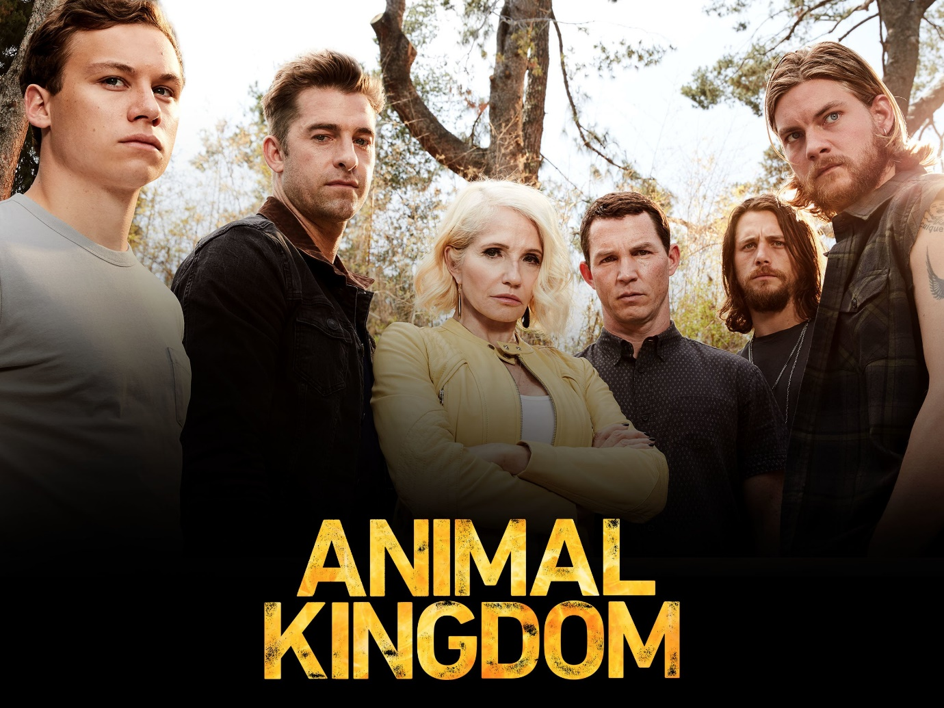

**Animal Kingdom**, an American **crime drama television series** grounded on the 2010 Australian film of the same name by David Michod. It's developed by Jonathan Lisco for **TNT** originally.

**Animal Kingdom Season 5: Release Date**

It was premiered for the first time on June 14, 2016. Then the **series** was **renewed** for **season** 2 in July 2016 which was released on May 30, 2017. The series was renewed for season 3 in July 2017 which was released on May 29, 2018. **Season** 4 renewal took place in July 2018, which was released on May 28, 2019. Then in July 2019, the creators of the show renewed the **series** for **season 5** which was likely to be **released** in 2020 as per the trends followed by the creators and distributors of the series. But owing to covid-19, the production got much delayed and the **release** is pushed to **2021**. As per the sources, the shoot was covered for few episodes before the lockdown, and then after lockdown restrictions removal, the cast members are back to the production. So, it's likely that **Season 5** will be released as soon as they wrap up the production. Even few characters have completed their role shoot for **season 5**, so that's a good sign for the work in progress. Additionally, as per the sources in January 2021, the creators renewed the series for season 6 which will be the final one. So, **season 5 release** is inevitable.

**Animal Kingdom season 5: Probable Cast**

All the lead actors are likely to repeat their characters. Though there may be few more actors. So, let's recap them one by one who appeared in the previous seasons and is likely to appear in **season 5**.

**Janine "Smurf" Cody** played by Ellen Barkin- She's the grandmother of Joshua Cody. She's a person who loves her family the most. Unfortunately, she's diagnosed with terminal cancer and thus she's willing to die on her terms. So, Joshua shots her dead as per her wish. She's dead so she's likely to appear in flashbacks and memories in season 5.

Barry "Baz" Blackwell played by Scott Speedman- He's Janine's adopted son and the leader of Cody's looting. At last, he's shot to death by Mia for plotting against Janine.

Andre "Pope" Cody played by Shawn Hatosy- He's the eldest Cody son who's mentally ill and tries to commit suicide. He was kept in Folsom State Prison for three years. He has feelings for Catherine, Baz's girlfriend. He feels attached to Lena, Catherine's daughter so he takes up the responsibility to protect her from the criminal Cody's family.

Craig Body played by Ben Robson- He's the second son of Cody's family and he has a liking for drugs and dangerous activities.

Deran Cody played by Jake Weary- He's the youngest Cody son, who is gay and manages a bar. He's also a fierce surfer.

**Joshua "J" Cody** played by Finn Cole- He's Janine's grandson. After the death of his mother, Julia he moves in to live with his grandmother and uncles. He's the one who dares to stand against Janine and lastly, he shoots her to death as per her willingness.

Catherine Blackwell played by Daniella Alonso- She's Barry's girlfriend and Lena's mother. She's choked to death by Andre on Janine's instructions.

Nicky Belmont played by Molly Gordon- She's Joshua's girlfriend and later on, she becomes Craig's girlfriend. She leaves town to live with her parents.

Lucy played by Carolina Guerra- She's Barry's girlfriend after Barry's wife, Catherine's death. She's a Mexican gang leader with her brother. Later on, she's shot by Mia.

Mia Benitez played by Sohvi Rodriguez- She's the love interest of Joshua. She's a tough trained woman. Later on, she's shot by Joshua when she reveals to her that she looted his family with her boyfriend Tupi and killed Baz. 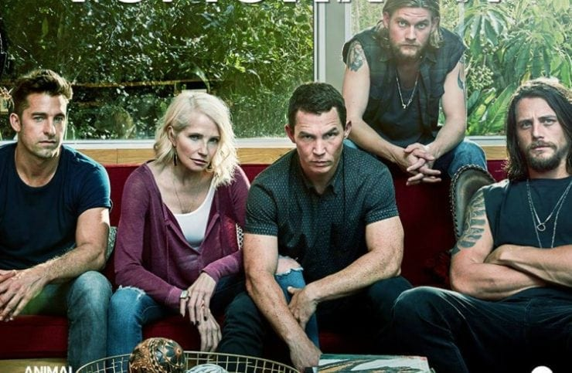

**Animal Kingdom Season 5: Expected Plot**

It's the story of **Joshua Cody**, a 17-year old boy, who moves to live with his grandmother and uncles following the death of his mother. His family is made up of criminal people only who're led by his grandmother **Janine**. So, season 5 is likely to revolve around Joshua and his family members who are associated with **criminal** activities, which becomes an integral part of their day-to-day life. So, we're likely to see Cody's family members losing their lives while combating criminal activities against each other while trying to become the supreme leader of the family leading everyone. They'll lose their life while trying to prove themselves as the best in front of others.

**Animal Kingdom Season 5: Trailer**

There's no official release of the **trailer** of **season 5**, so till that time you can enjoy the **Animal Kingdom Season** 4 **trailer** and recap your memories😊

https://www.youtube.com/watch?v=SaQhx0jBPyE